Programming Assignment #7

(for Ch 8)

Problem Description

Write a program that stores lists of names (the last name first) and ages in parallel arrays and sorts the names into alphabetical order keeping the ages with the correct names. The original arrays of names and ages should remain no changes. Therefore, you need to create an array of character pointers to store the addresses of the names in the name array initially. Apply the selection sort to this array of pointers so that the corresponding names are in alphabetical order. See the sample program of Fig.8.14 from pages 479 to 481 in the textbook. You should use another array of pointers to age array to make sure the age is corresponding to the correct name.

Sample Run

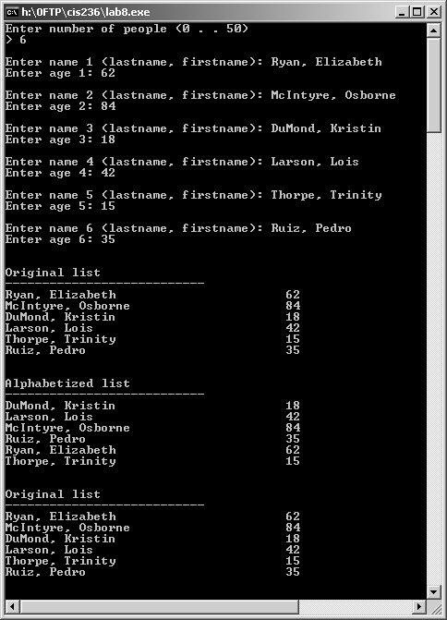

Problem Requirement
a) You must create a program file and save it as Program7.c file.
b) Your program should run correctly with the same inputs and outputs as given in the sample run.

